Fresh Eggs  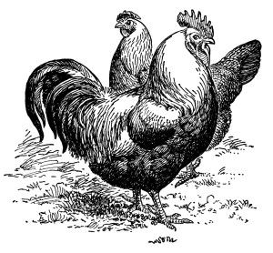  [insert your  farm name] | Fresh Eggs  [insert your  farm name] | Fresh Eggs  [insert your  farm name]
Fresh Eggs  [insert your  farm name] | Fresh Eggs  [insert your  farm name] | Fresh Eggs  [insert your  farm name]
Fresh Eggs  [insert your  farm name] | Fresh Eggs  [insert your  farm name] | Fresh Eggs  [insert your  farm name]
“FRESH EGGS LABEL TEMPLATE” - LIFE AT CLOVERHILL / AMANDA GORDON - www.lifeatcloverhill.com
Store in fridge for up  to one month.  ···  Wash with warm soapy water  prior to use. | Store in fridge for up  to one month.  ···  Wash with warm soapy water  prior to use. | Store in fridge for up  to one month.  ···  Wash with warm soapy water  prior to use.
Store in fridge for up  to one month.  ···  Wash with warm soapy water  prior to use. | Store in fridge for up  to one month.  ···  Wash with warm soapy water  prior to use. | Store in fridge for up  to one month.  ···  Wash with warm soapy water  prior to use.
Store in fridge for up  to one month.  ···  Wash with warm soapy water  prior to use. | Store in fridge for up  to one month.  ···  Wash with warm soapy water  prior to use. | Store in fridge for up  to one month.  ···  Wash with warm soapy water  prior to use.
“FRESH EGGS LABEL TEMPLATE” - LIFE AT CLOVERHILL / AMANDA GORDON - www.lifeatcloverhill.com

